HH random Forest

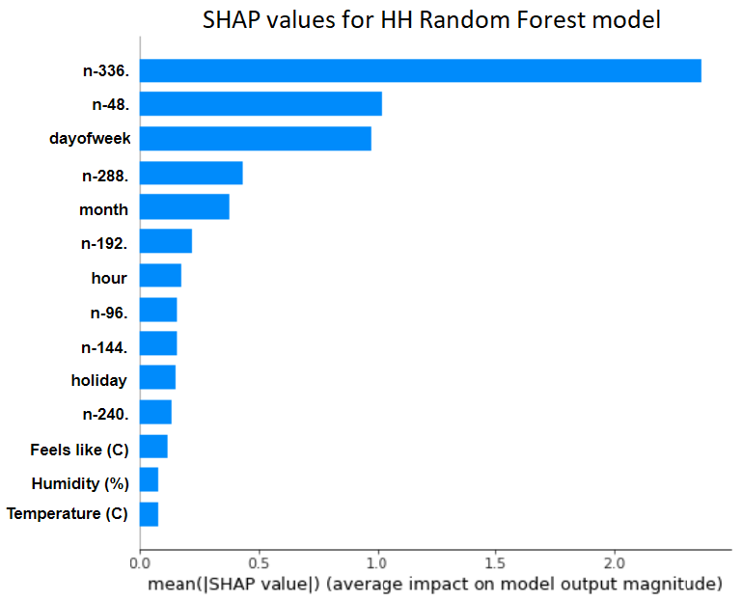

As we can see, “n - 7 days” feature has the largest effect on predictions globally. The other past values features also rank high whilst the exogenous factors such as weather circumstances only have small effects.

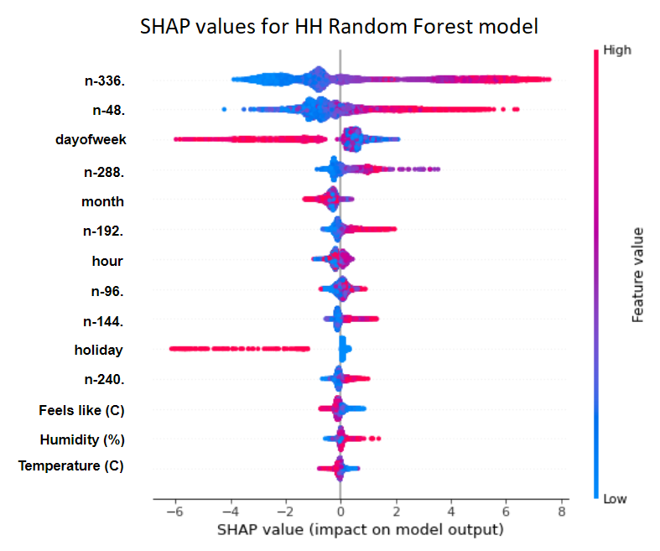

### The figure above depicts how for each value for a feature what effect it had on the prediction. As we can see most features behave the way we would expect as in when the value was low/high the effect had a positive/negative effect.

### Local interpretability:

To further investigate we analyse specific predictions locally.

#### Incorrect forecast

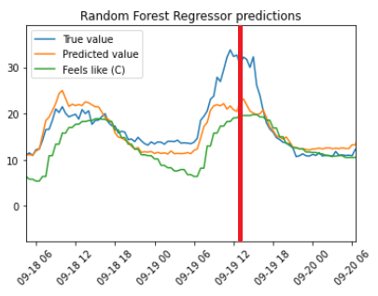

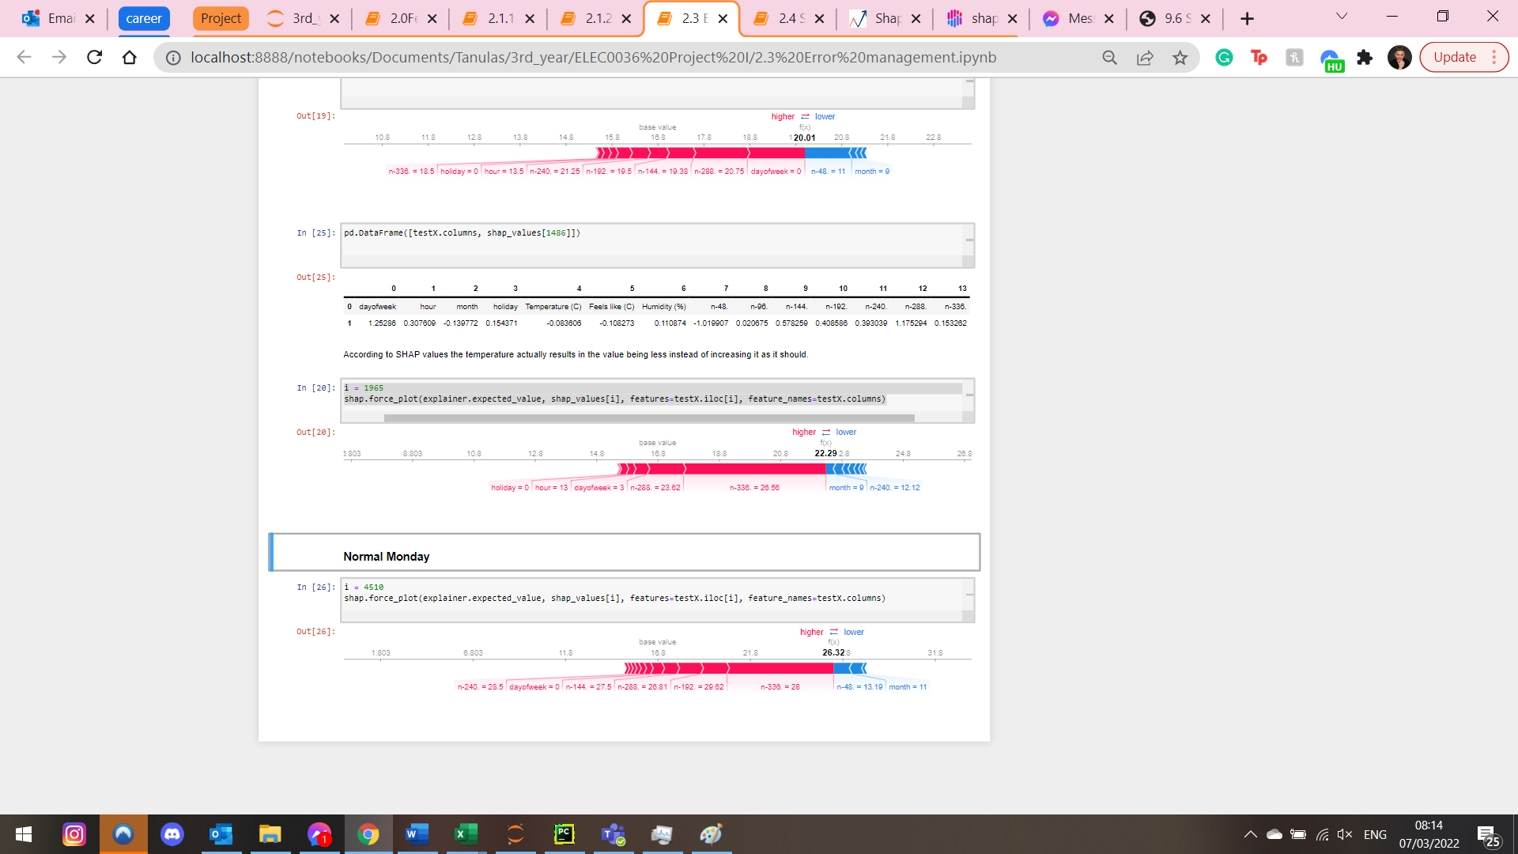

Accurate Monday 13:30

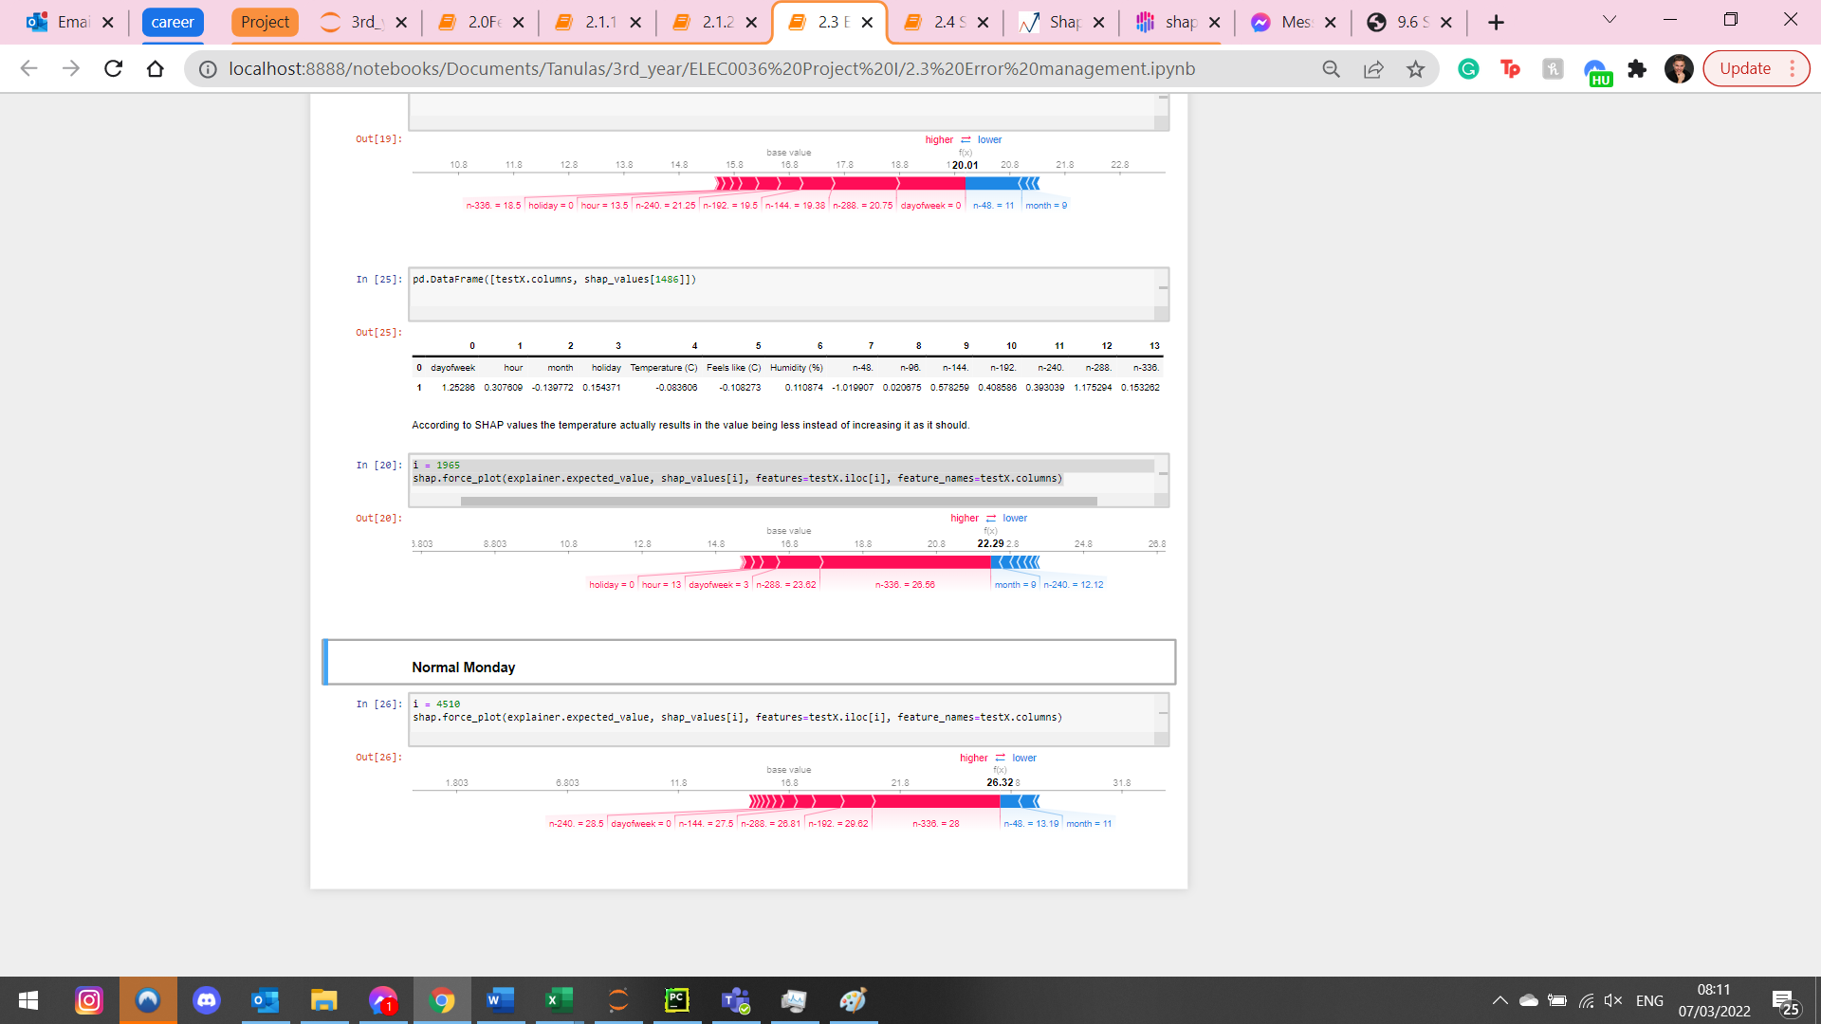

Accurate Wednesday 1:00

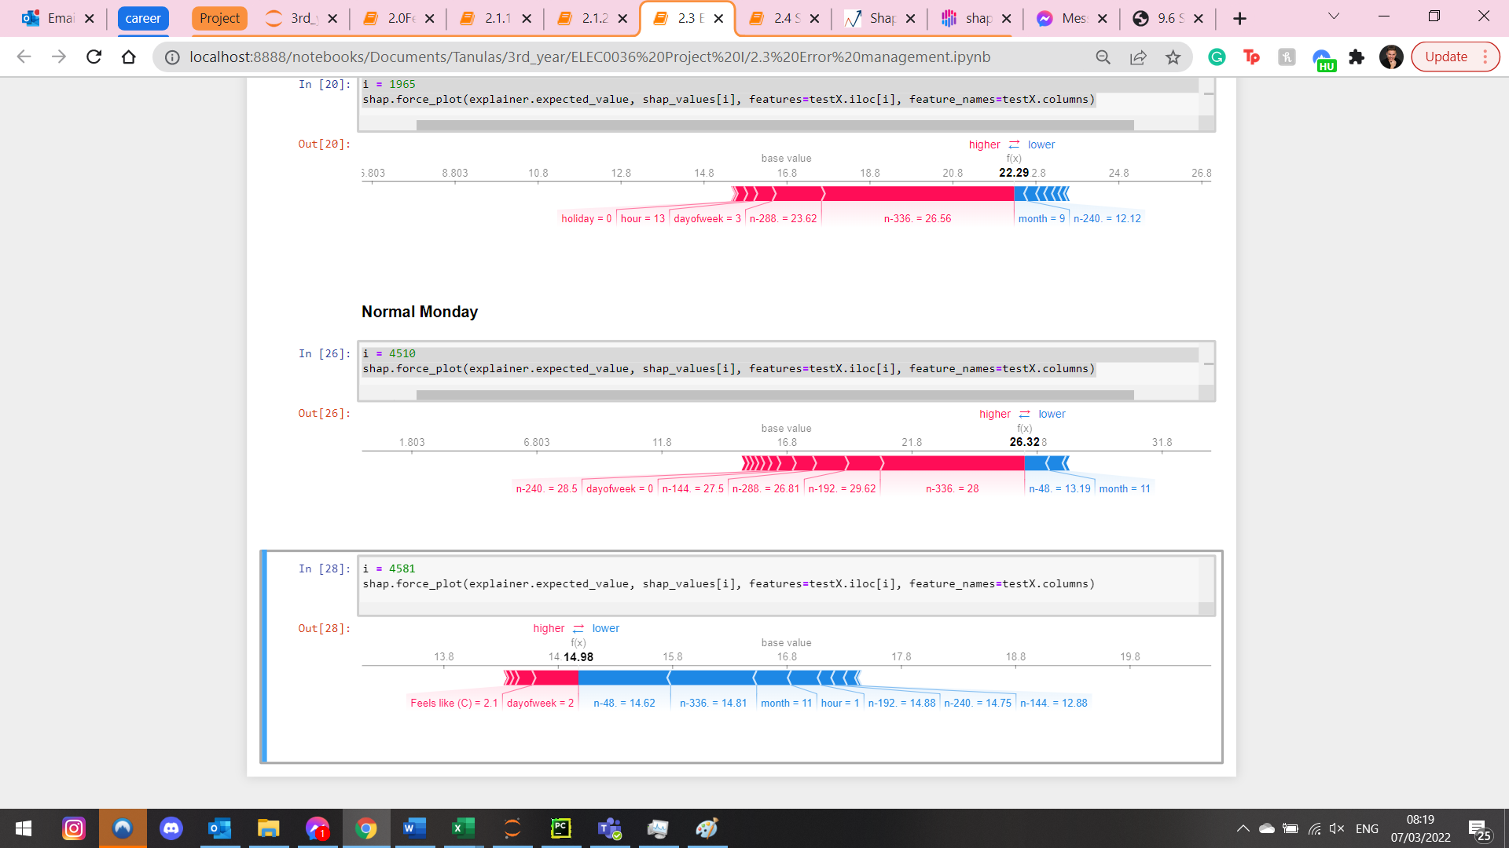

Accurate Sept Weekend

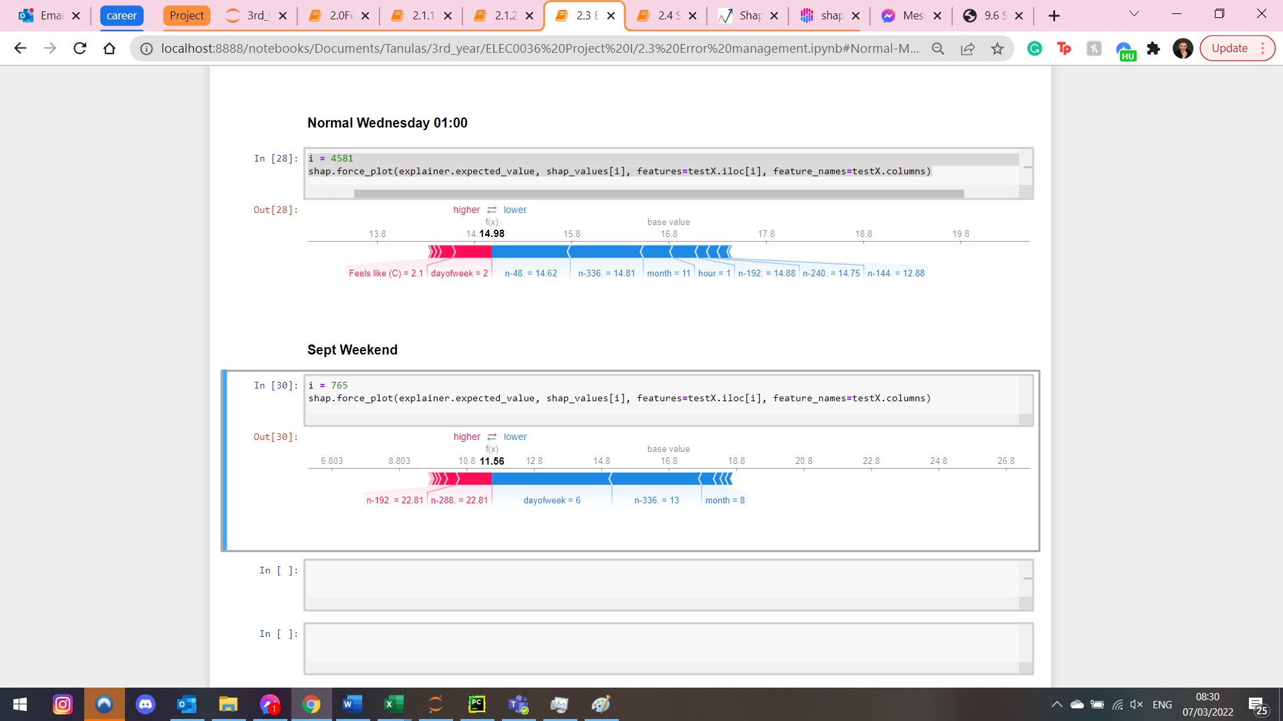

#### Holiday

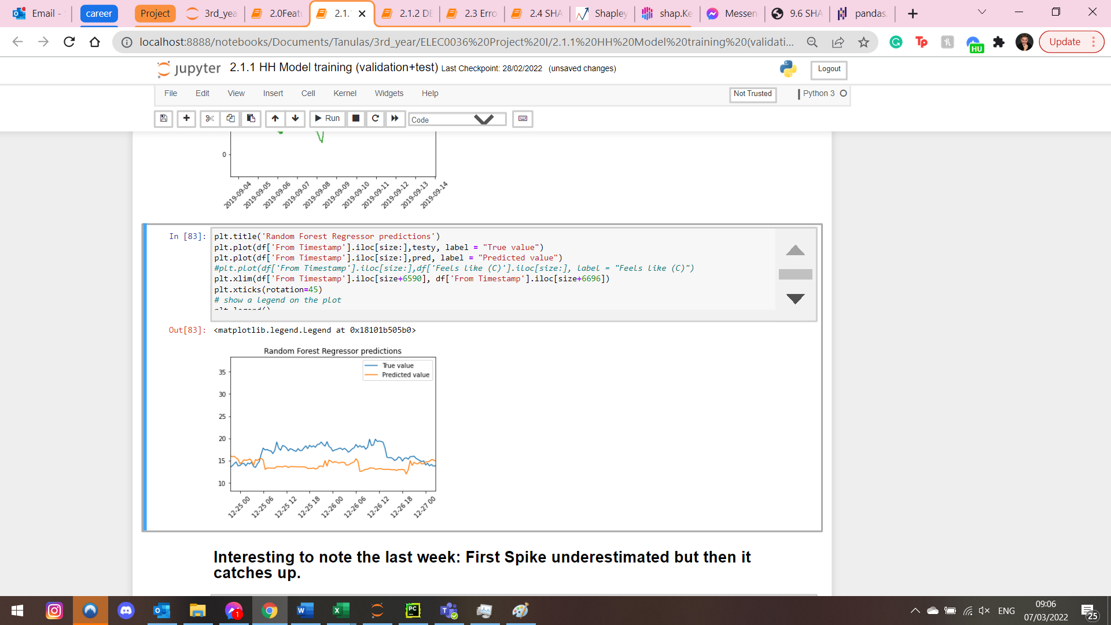

We underestimate the values

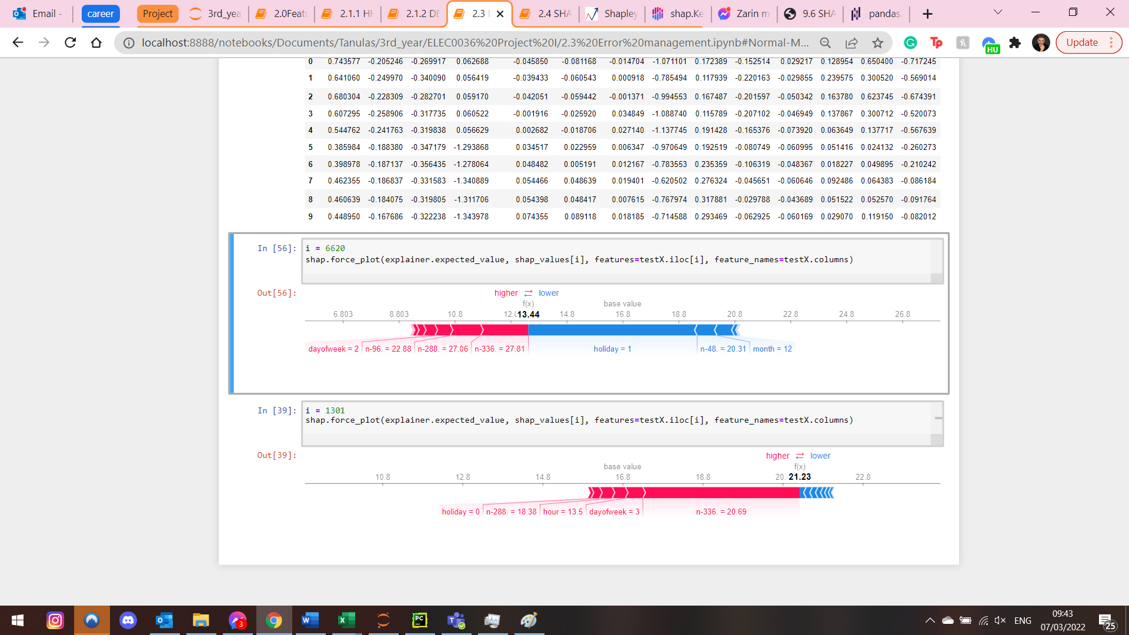

We can see that weather conditions never really had a significant effect on the model. This proposes that it might be the weakness of the model. Targeting this weakness in future work might be beneficial.

DE SVM

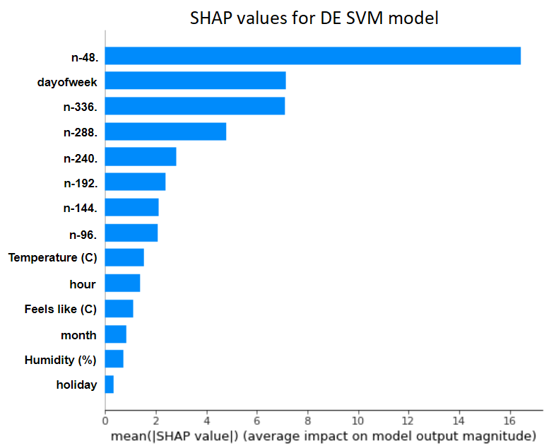

For DE the previous day feature was the most relevant

We can see that weather conditions ranked higher this time.

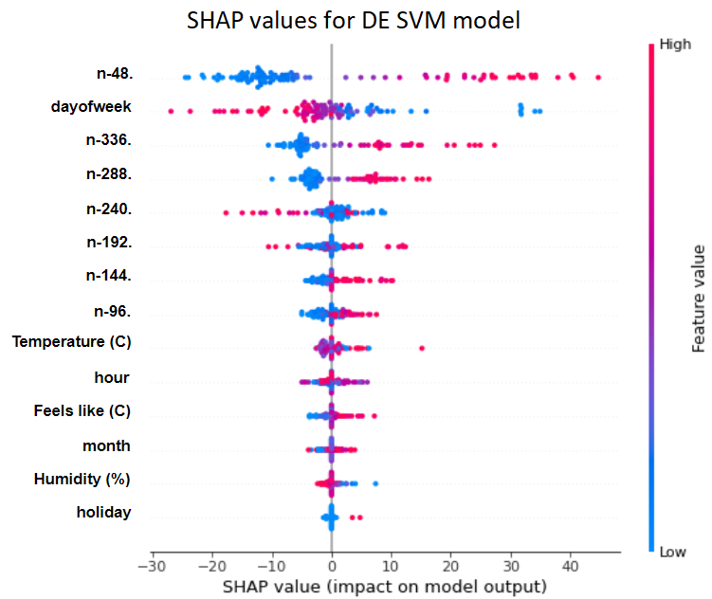

Due to the high computational expenses of Kernel shap only 100 instances were analysed for global interpretability. The results are similar as before with the main difference of weather effects which are due to the different profiles of the two houses.

Local interpretability

Monday 12:30

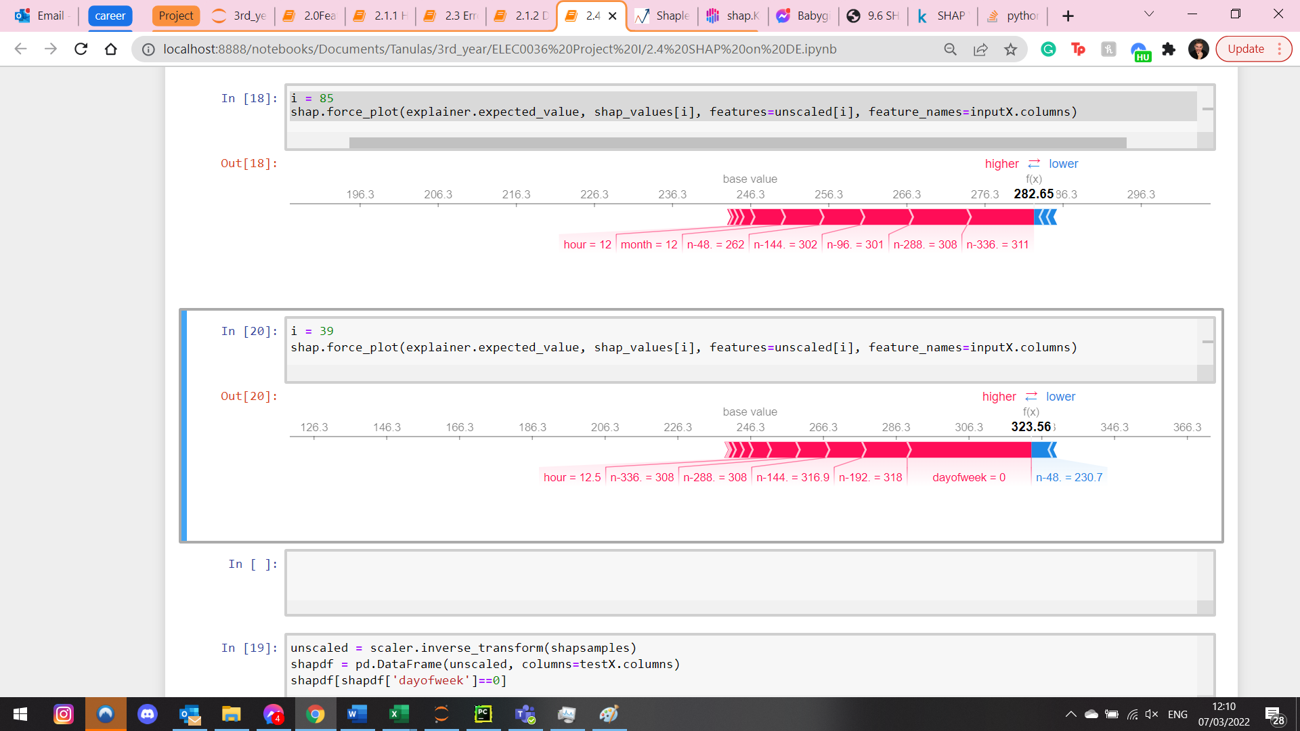

Wednesday 12:00

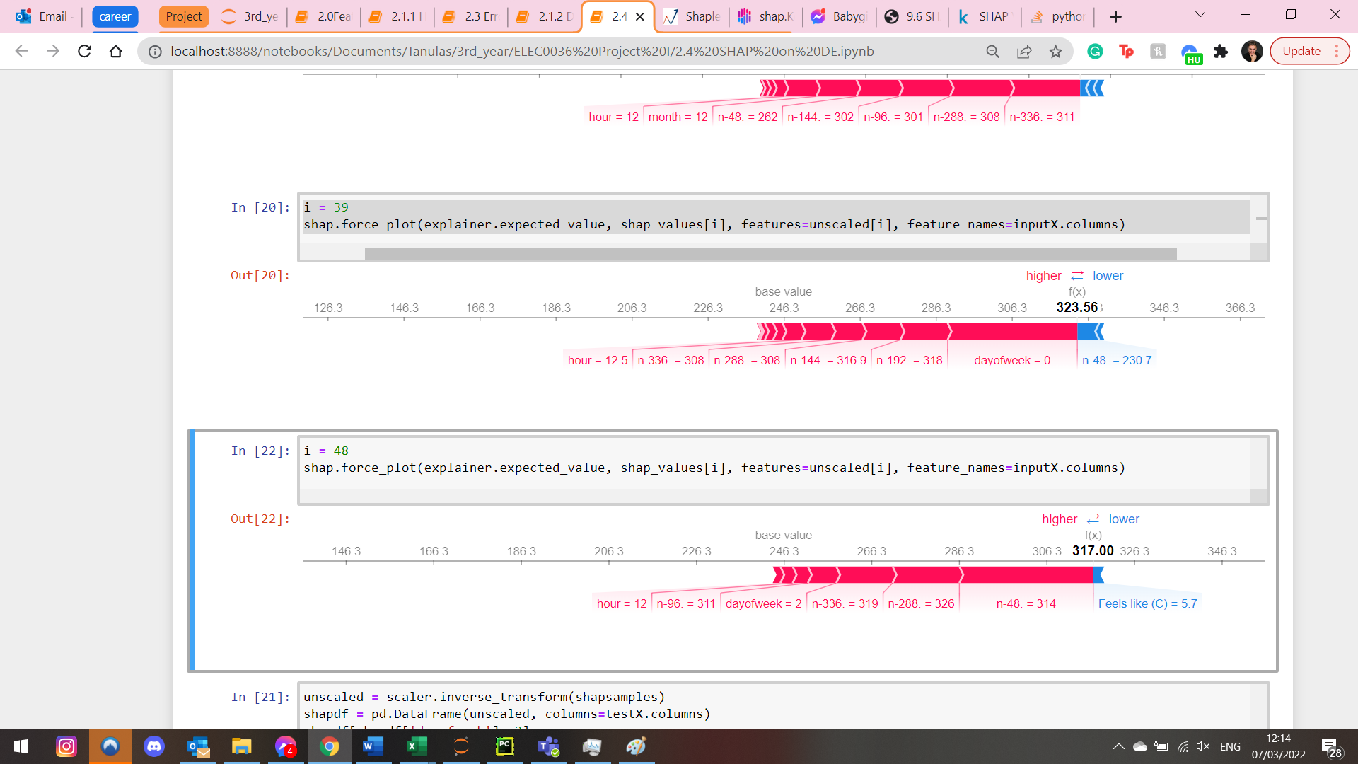

Only difference is the amount of importance for ‘n-48’ or ‘day 0’

We can see that Feels like finally had an effect on the model!

Weekend

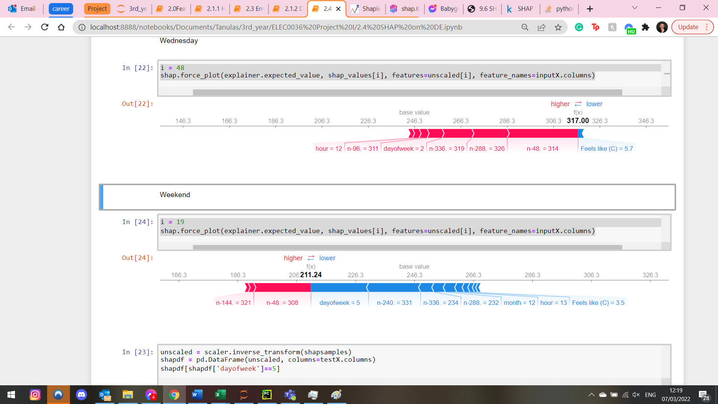

Out of working hours 1:30 am

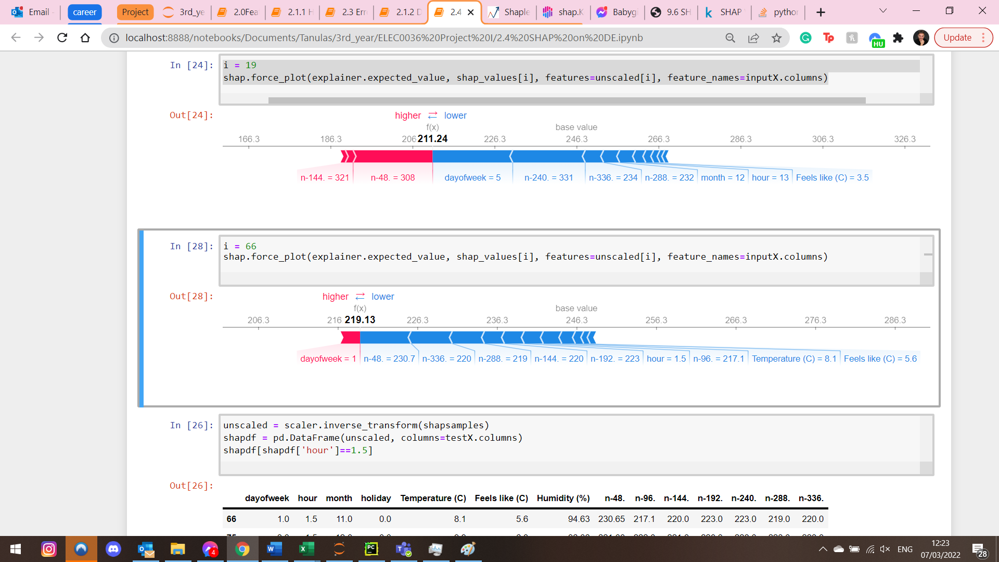

Temperature has effect!

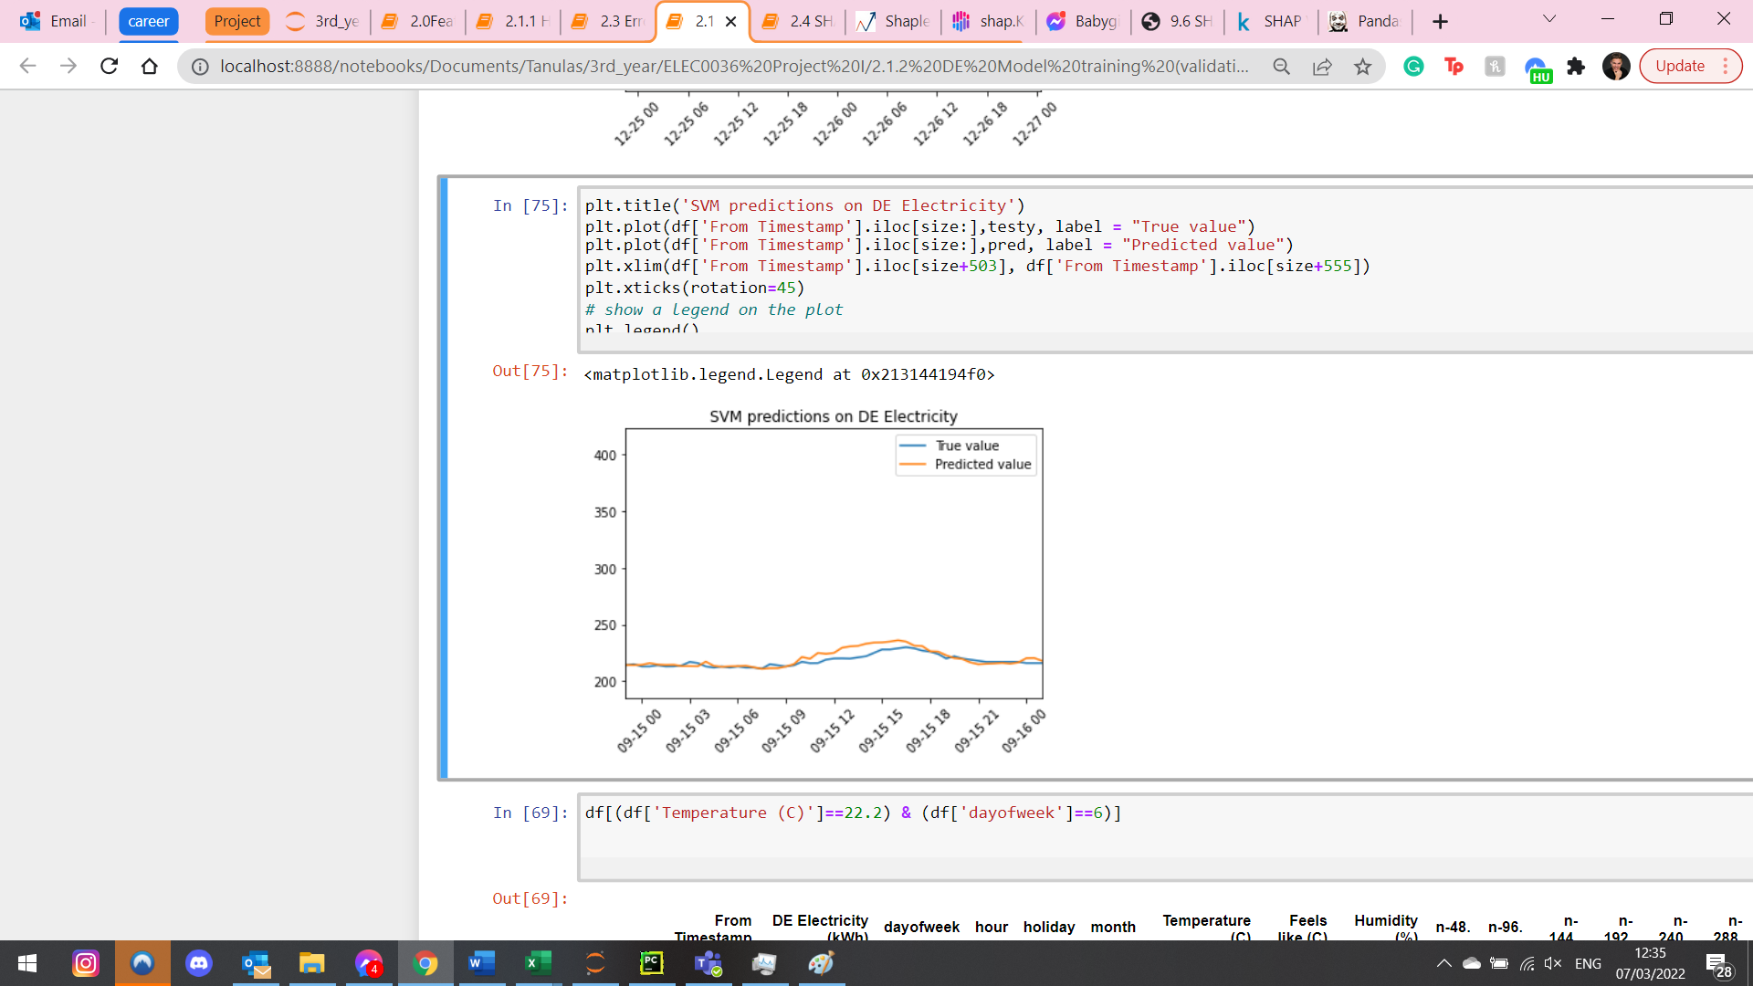

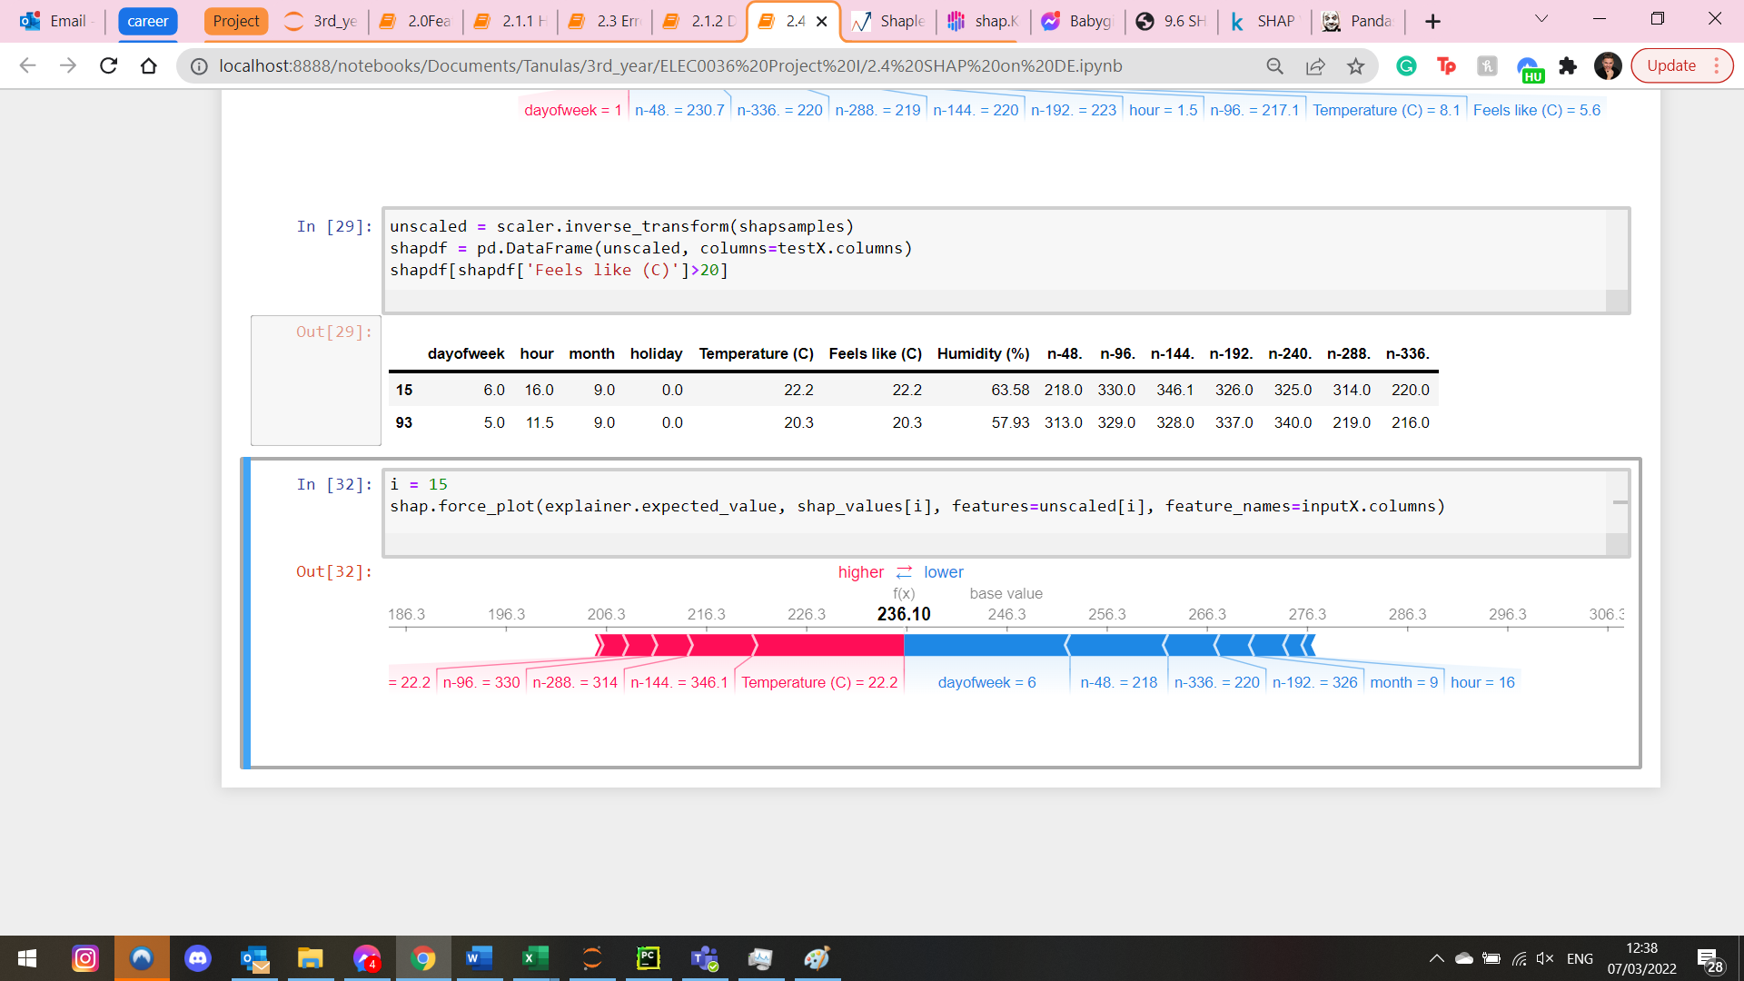

Investigate temperature on HH again:

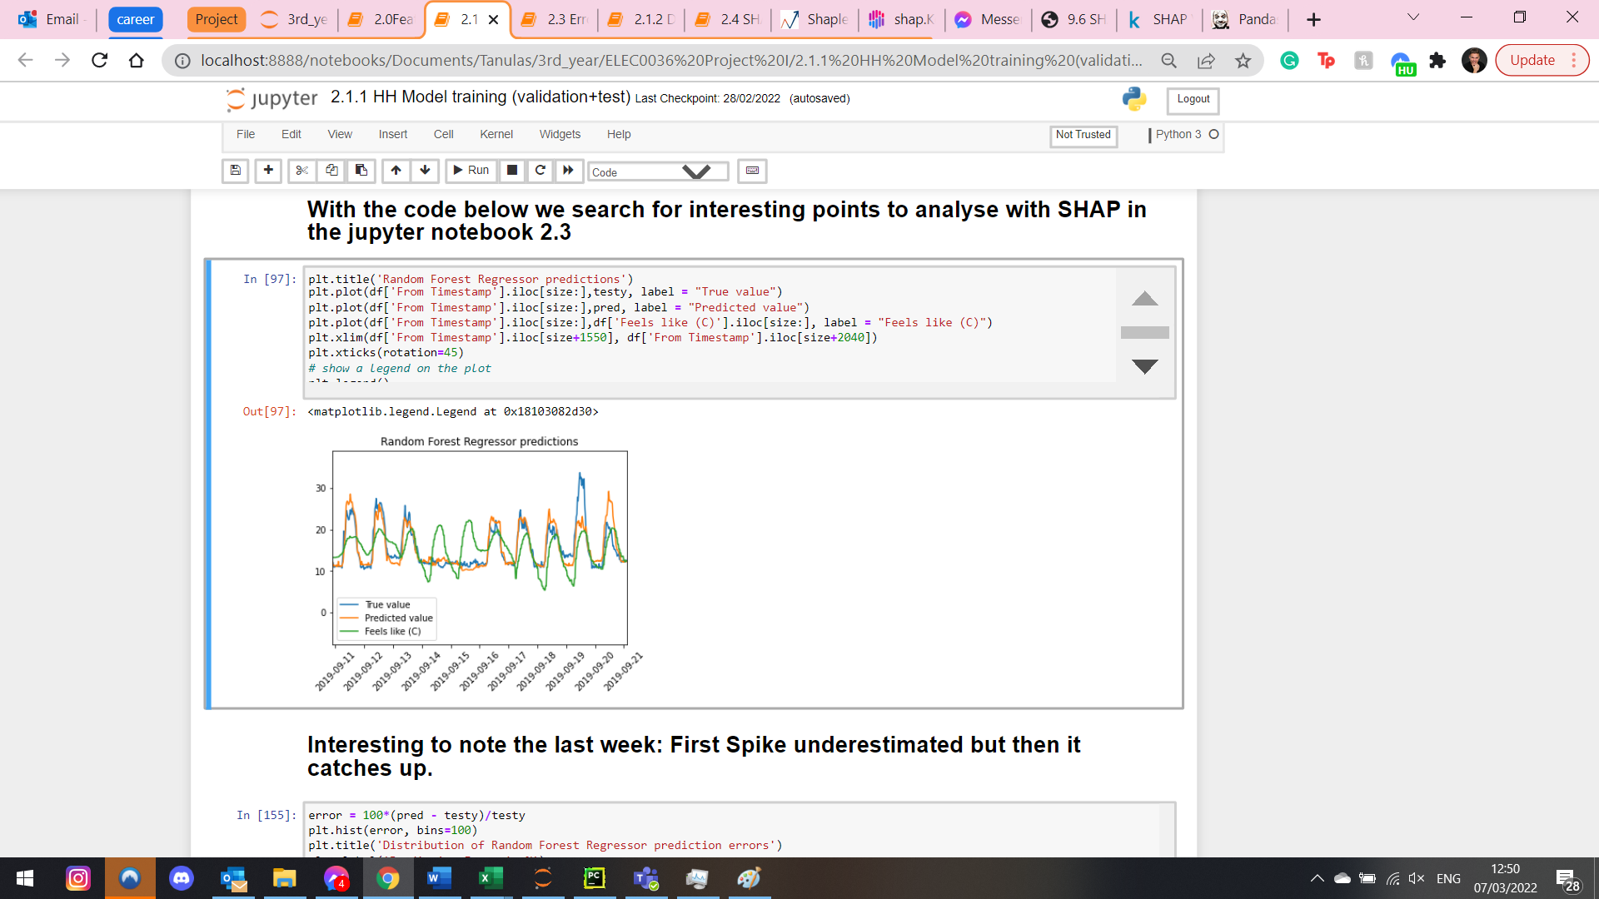

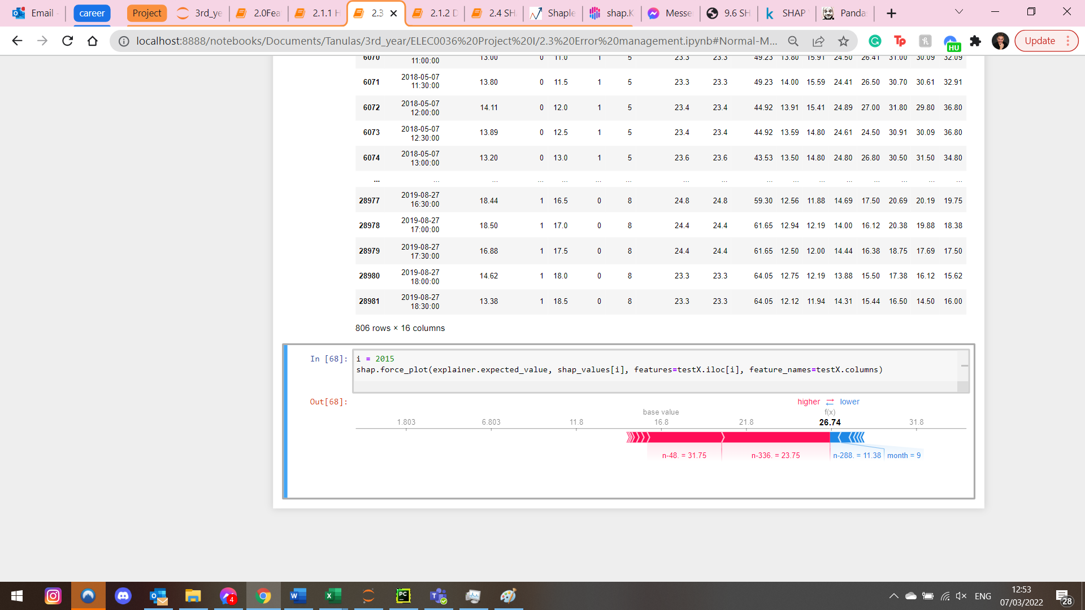

Tried several high temperature values but no effect

Cold:

